- HOME OWNERS
- ENGINEERS & ARCHITECTS
- CONTRACTORS
- DEALERS

Select Language​▼
- ABOUT US
- WALLS

- PAVERS

- DESIGN INSPIRATION
- WHERE TO BUY
- EVENTS
- BLOG
- RESOURCES

- 8 & UNDER
- CONTACT

Fortus Square Foot - Willow

Fortus Square Foot

Retaining Wall System
The Fortus Square Foot™ system redefines the way retaining walls are designed and built. Ideal for everything from residential landscaping to commercial projects, Fortus Square Foot’s beautiful and distinctive color blends are unsurpassed in the industry and feature a perfect combination of beauty and strength. Bring your dreams to reality through Fortus Square Foot’s maximum layout creativity when building curves, corners and angles as well as set-back or near-vertical walls. Due to its patented SecureLug™ Variable Connection System, The Fortus Square Foot™ system combines durable, precast concrete with incredible ease of installation. When stacked and filled with aggregate, the lightweight and easy to handle Fortus Square Foot™ units interlock, providing high shear resistance and excellent connection strength to geosynthetic reinforcement, if required. For value, beauty, durability and ease of construction, your best choice is the Fortus Square Foot™ Retaining Wall System by LibertyStone™ Hardscaping Systems.
- 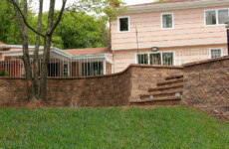
- 
- 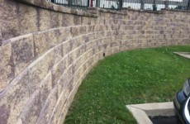
- 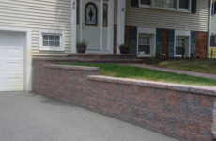
- 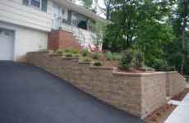
- 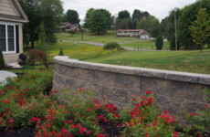
- 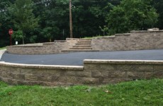
- 1
- 2
- <
- >
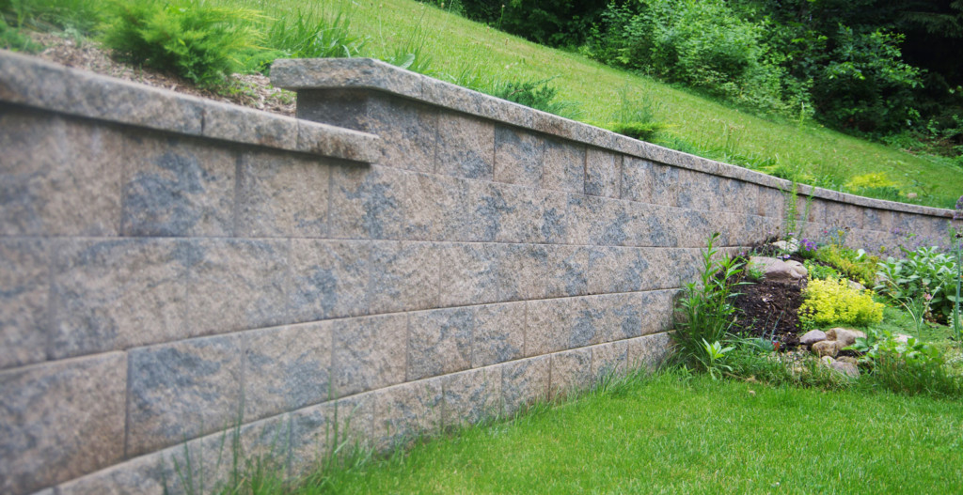
- Ultra-light weight for improved shipping and handling
- Variable SecureLug™ Connection System allows for set-back & near vertical wall installation
- Recessed “hand-holds” allow for the unit to be installed with incredible ease
- Increased vertical drainage through the units
- Strong and reliable connection between units and geosynthetic reinforcement

SecureLug™ Variable Connection System
Fortus Square Foot™ has been thoroughly tested for connection and strength in accordance with the design methodology promoted by the National Concrete Masonry Association (NCMA). Fortus Square Foot’s patented SecureLug™ Variable Connection System, when combined with gravel infill and geosynthetic reinforcement creates a strong, long lasting retaining wall. Fortus Square Foot™ can be built with a standard set-back, through the use of its segmented rear lugs, or installed near-vertical, by removing the rear lugs and engaging its center lugs. Regardless of which set-back that’s chosen, Fortus Square Foot’s Variable SecureLug™ connection system allows for significant lateral movement without losing the connection interlock. Fortus Square Foot™ walls flex with seismic pressures and resist weathering. The hollow core of each unit provides excellent drainage, reducing the buildup of hydrostatic pressure. The light weight Fortus Square Foot™ unit does not require the use of expensive pins or clips and promotes layout flexibility, while saving time and expense during installation.
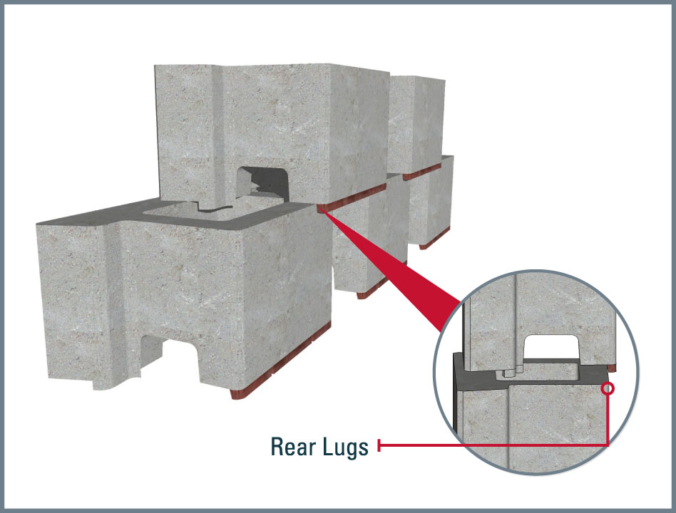
Use Rear Lugs for typical Setback Walls
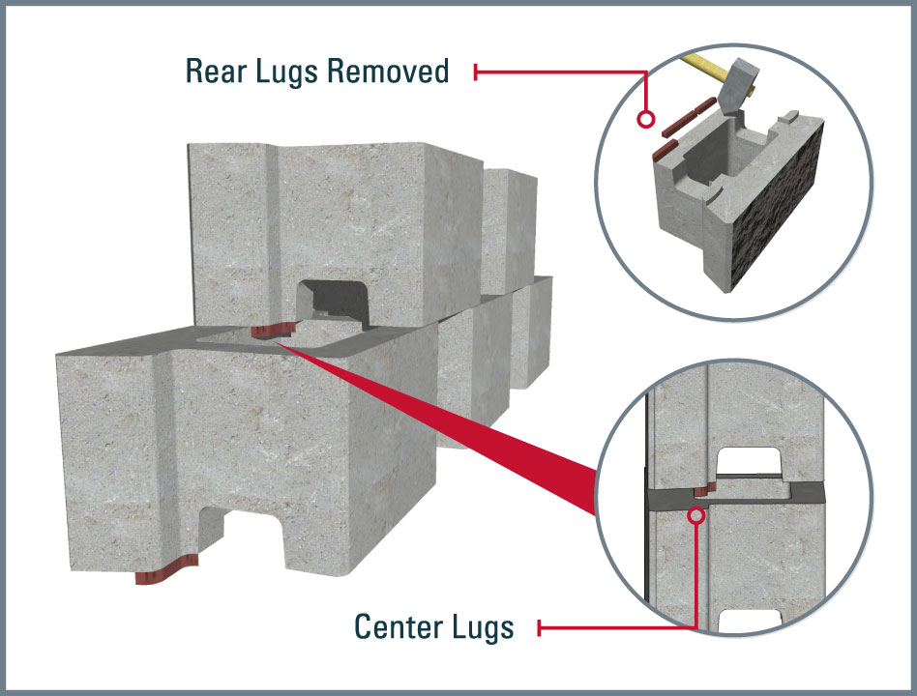
Use Center Lugs for Near Vertical Walls

Fortus Square Foot Colors
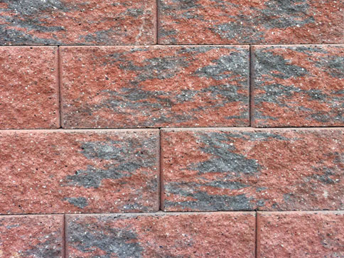
Brandy
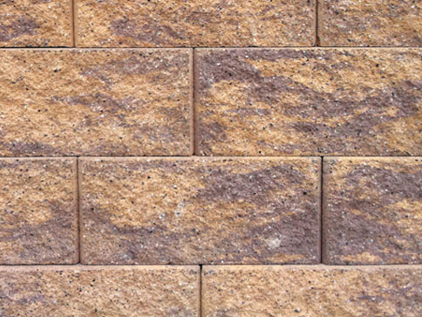
Chestnut
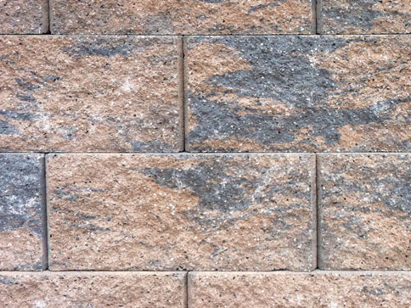
Desert
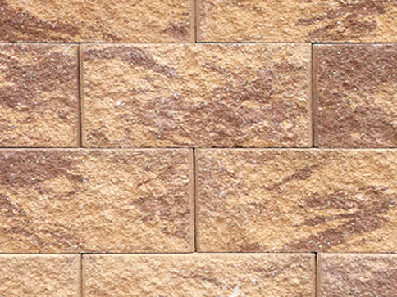
Nutmeg
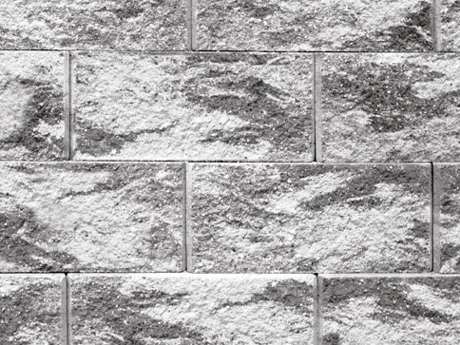
Willow
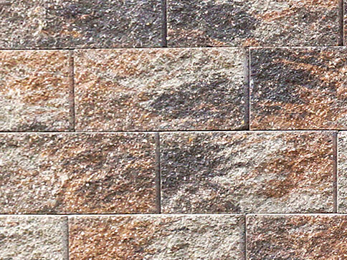
West Mountain Blend

Fortus Square Foot Units
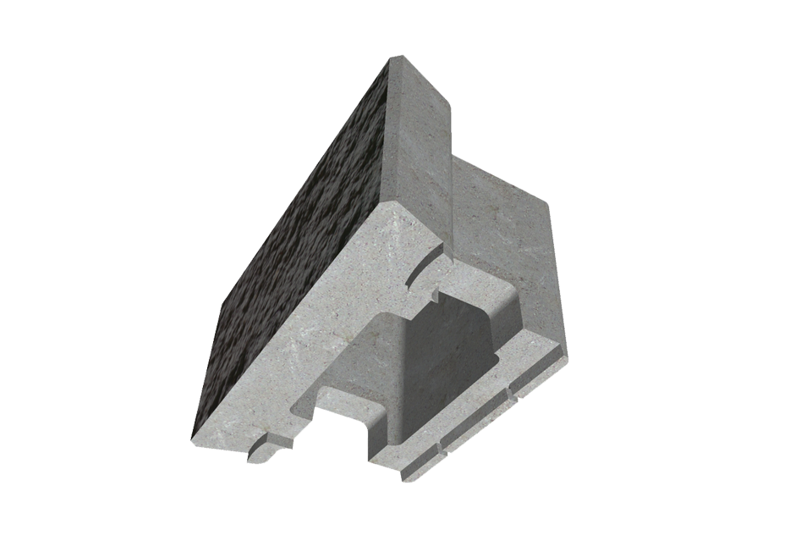
Fortus Square Foot Unit
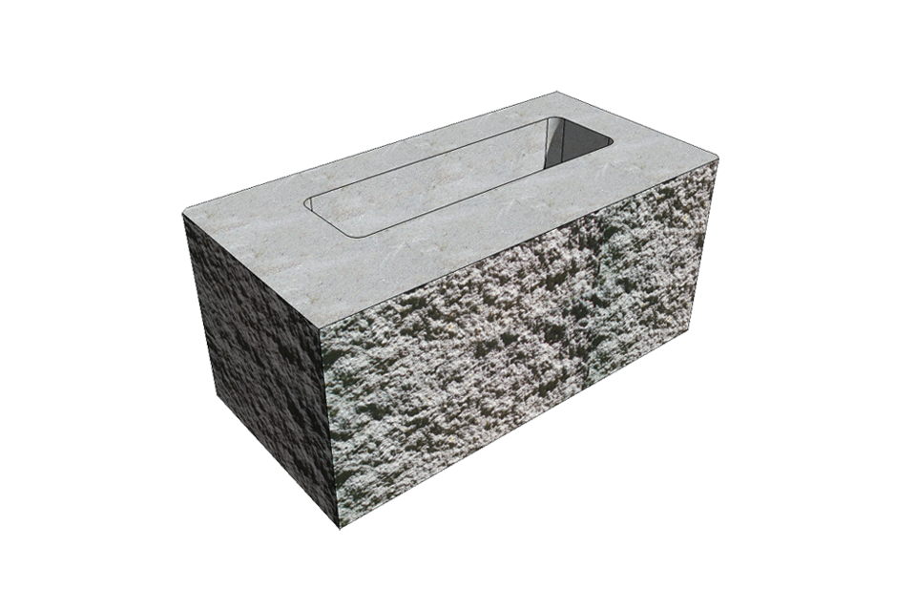
8″ Universal 90° Corner Unit
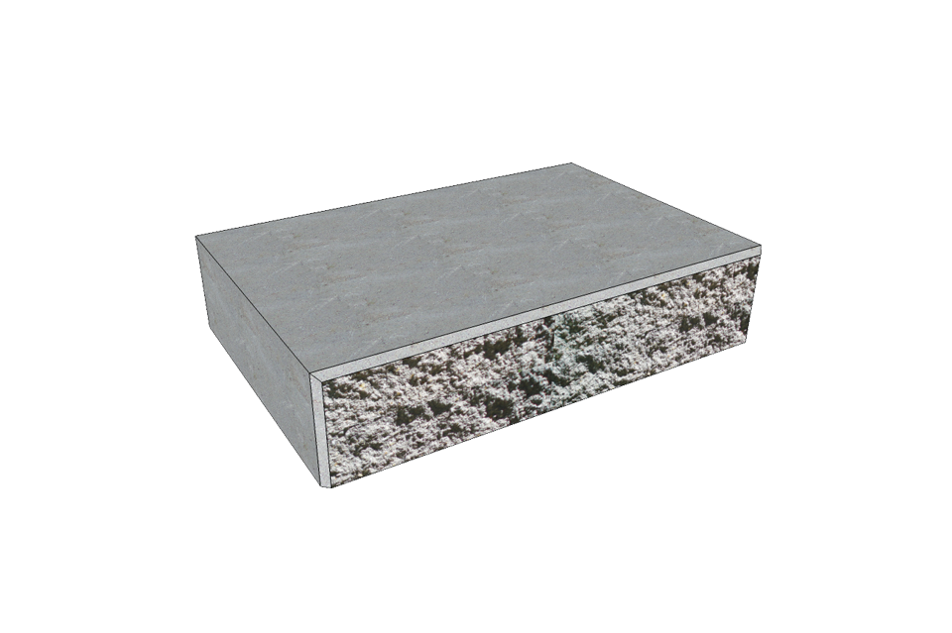
3″ Universal Wall Cap

Forts Square Foot Specifications
HEIGHT | LENGTH | WIDTH | SQ FT/PIECE | SQ FT/CUBE | Pieces/Cube
8″ | 18″ | 10″ | 1 | 40 | 40

8″ Universal 90° Corner Unit Specifications
HEIGHT | LENGTH | WIDTH | SQ FT/PIECE | SQ FT/CUBE | Pieces/Cube
8″ | 18″ | 8″ | 1 | 40 | 40

3″ Universal Wall Cap Specifications
HEIGHT | LENGTH | WIDTH | SQ FT/PIECE | SQ FT/CUBE | Pieces/Cube
3″ | 18″ | 12″ | 0.375 | 24 | 64

Where to Buy
LibertyStone products can be found across the Northeastern United States. To serve you best, find a dealer that’s close to you to help you find the product that best suits your project needs and vision!
LETS GO!

Technical, CAD, and Literature

Literature / Resources
- Forts Square Foot™ Brochure
- Forts Square Foot™ Installation Guide

Similar Products
- 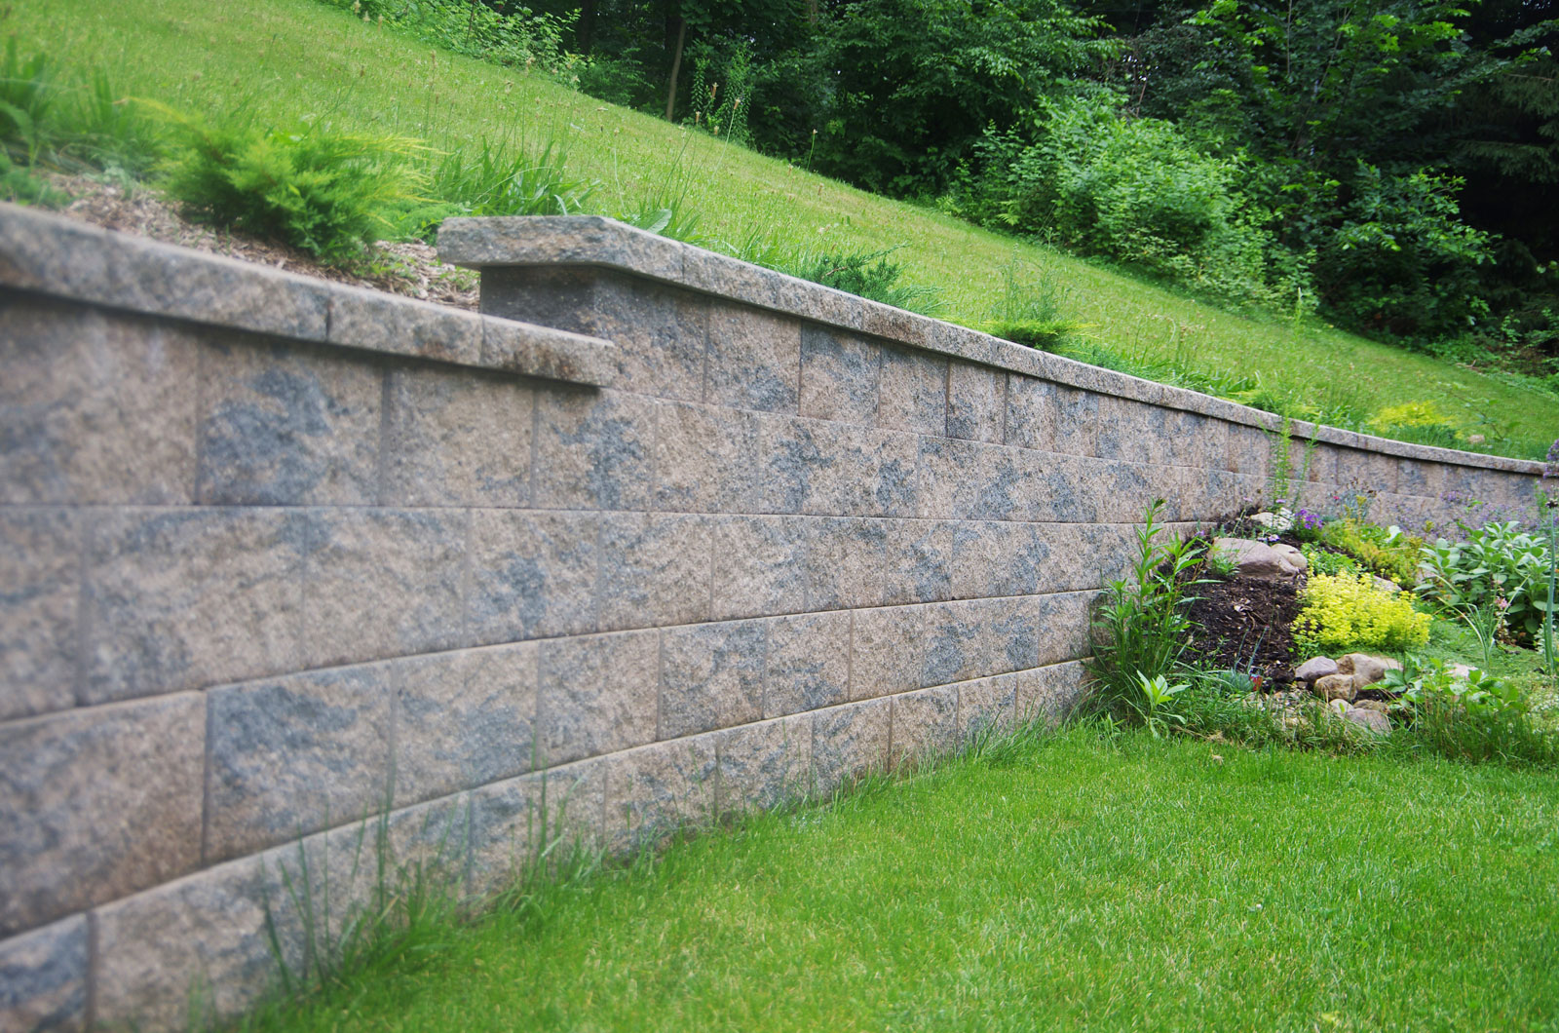

Fortus Square Foot
- 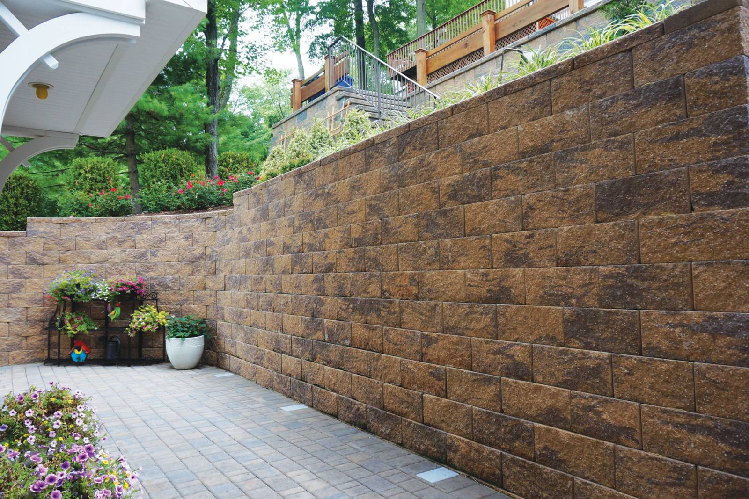

CornerStone 8″ Straight Face
- 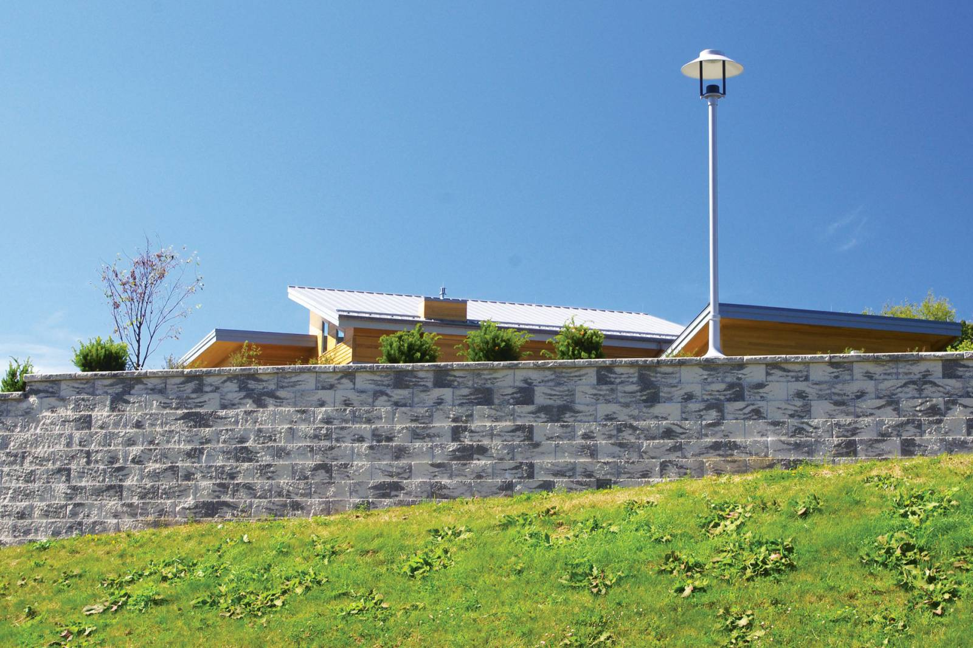

Keystone 8″ Compac III
- 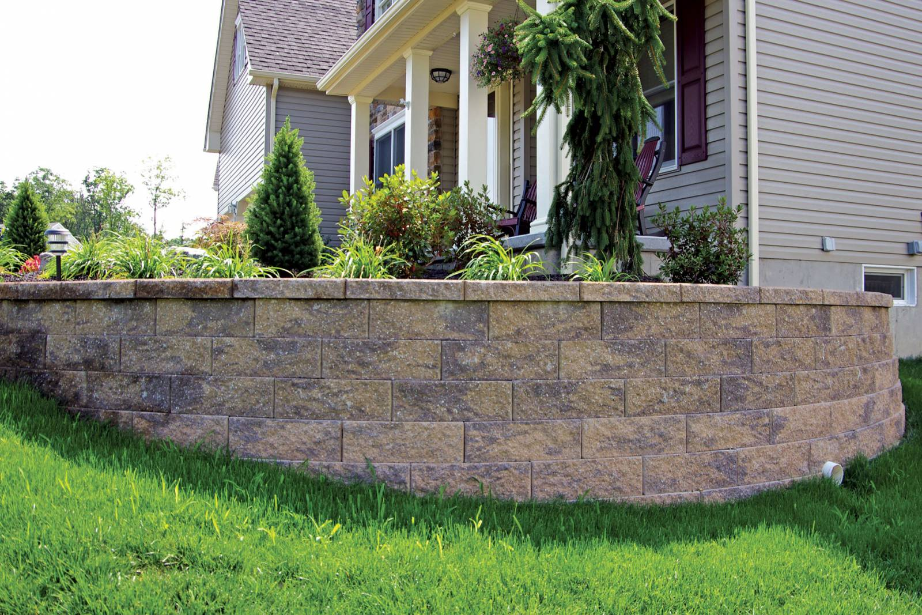

MiraStone 6″
- 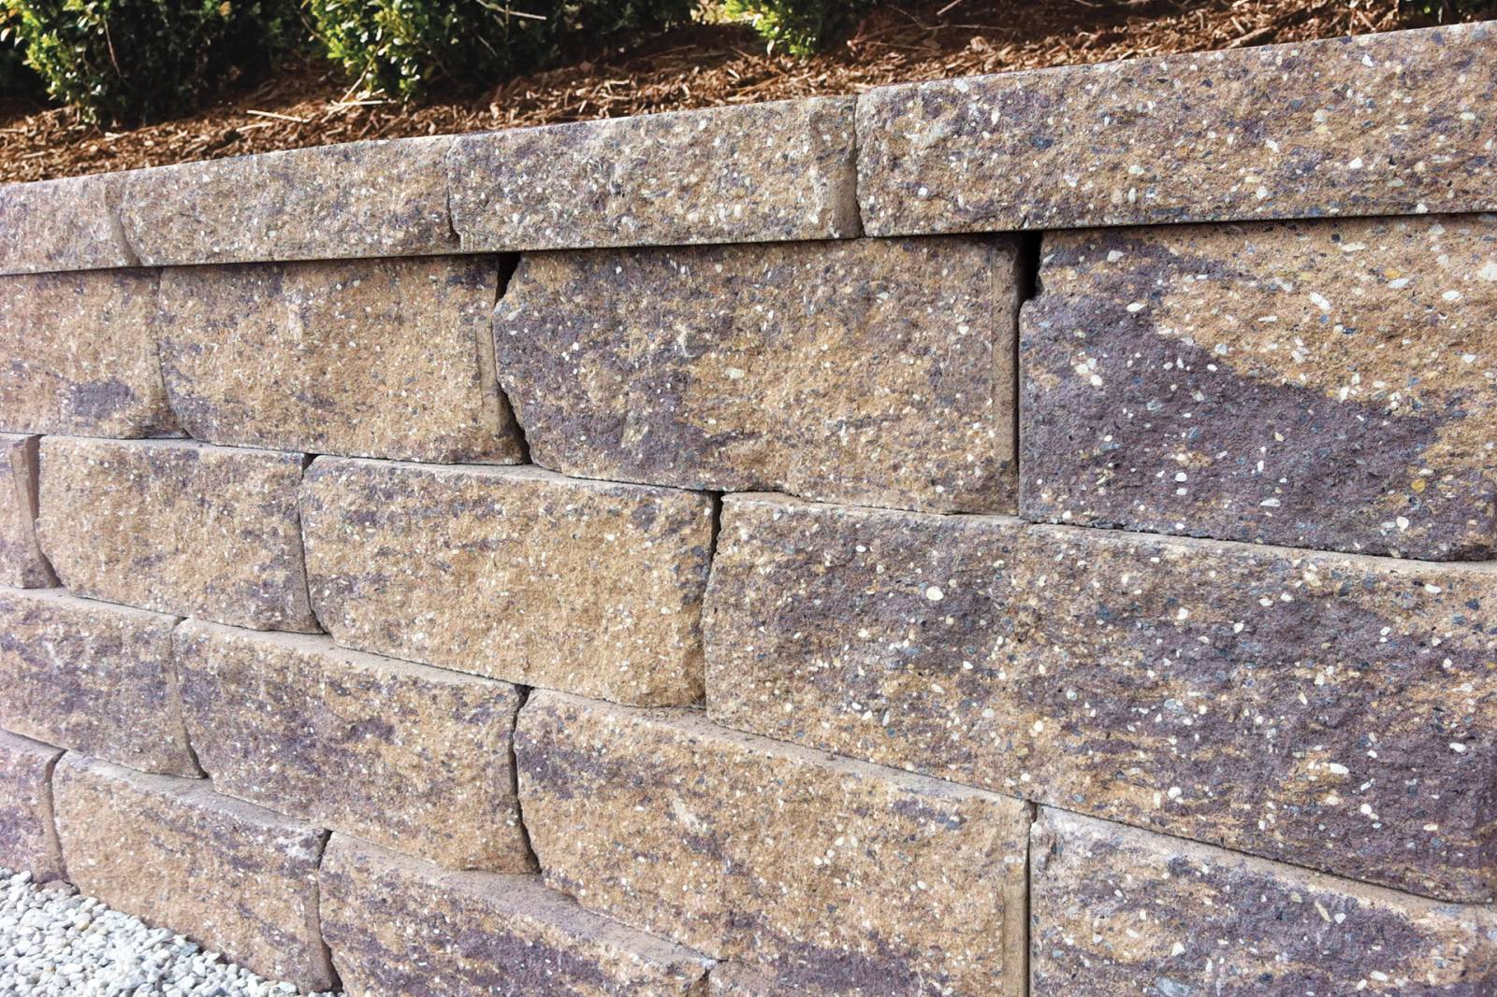

Legacy Rustic 6″
- 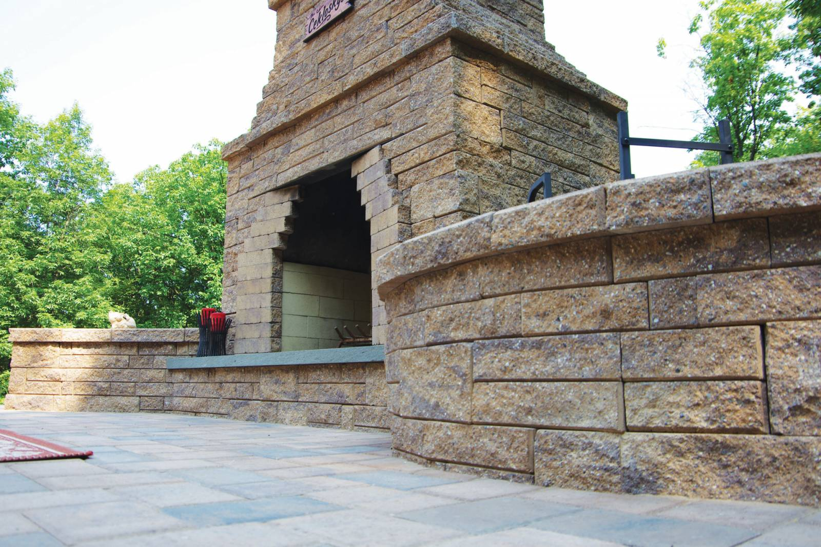

Stonevista 3” & 6” Ashlar
- 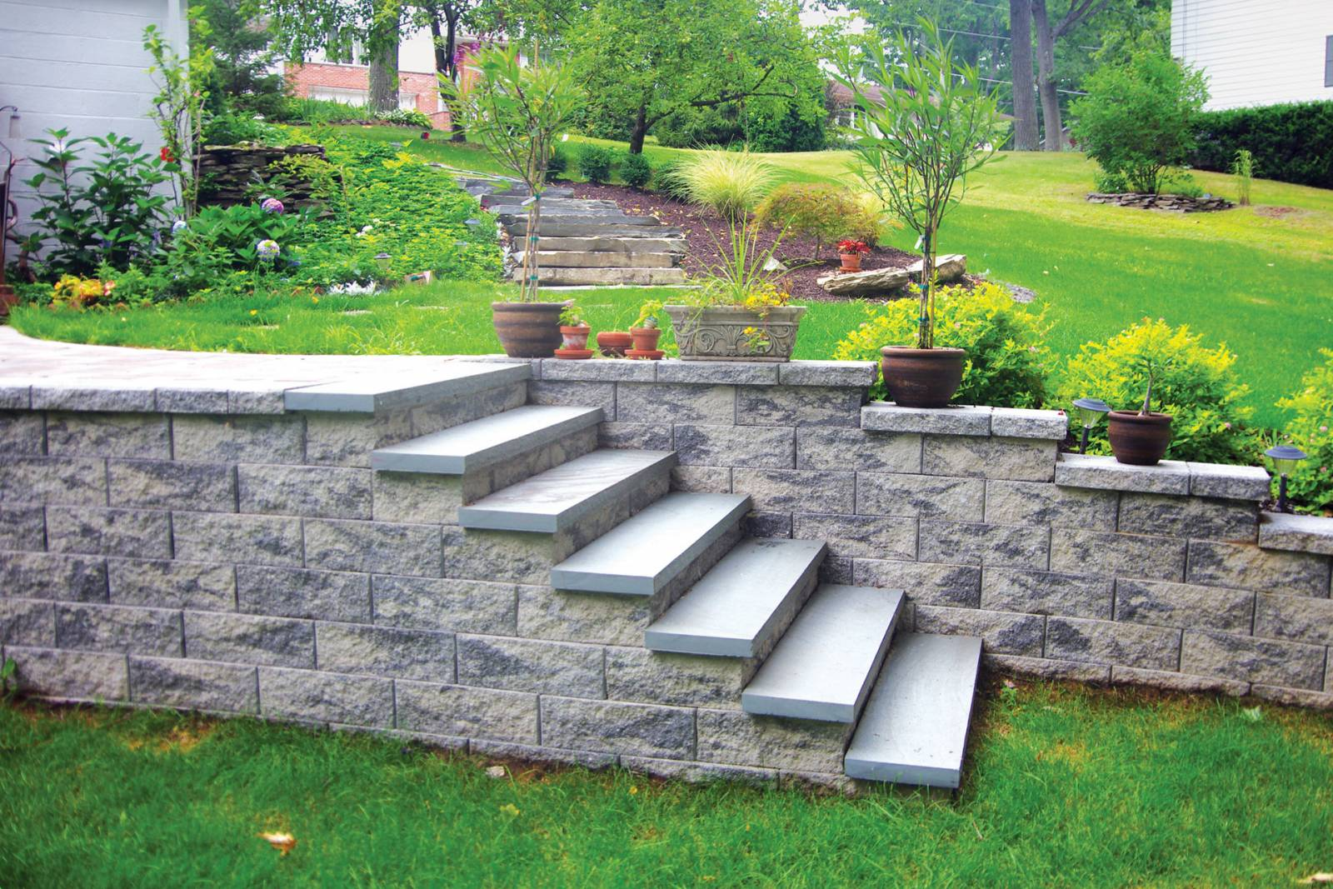

Stonevista 6” Standard
- 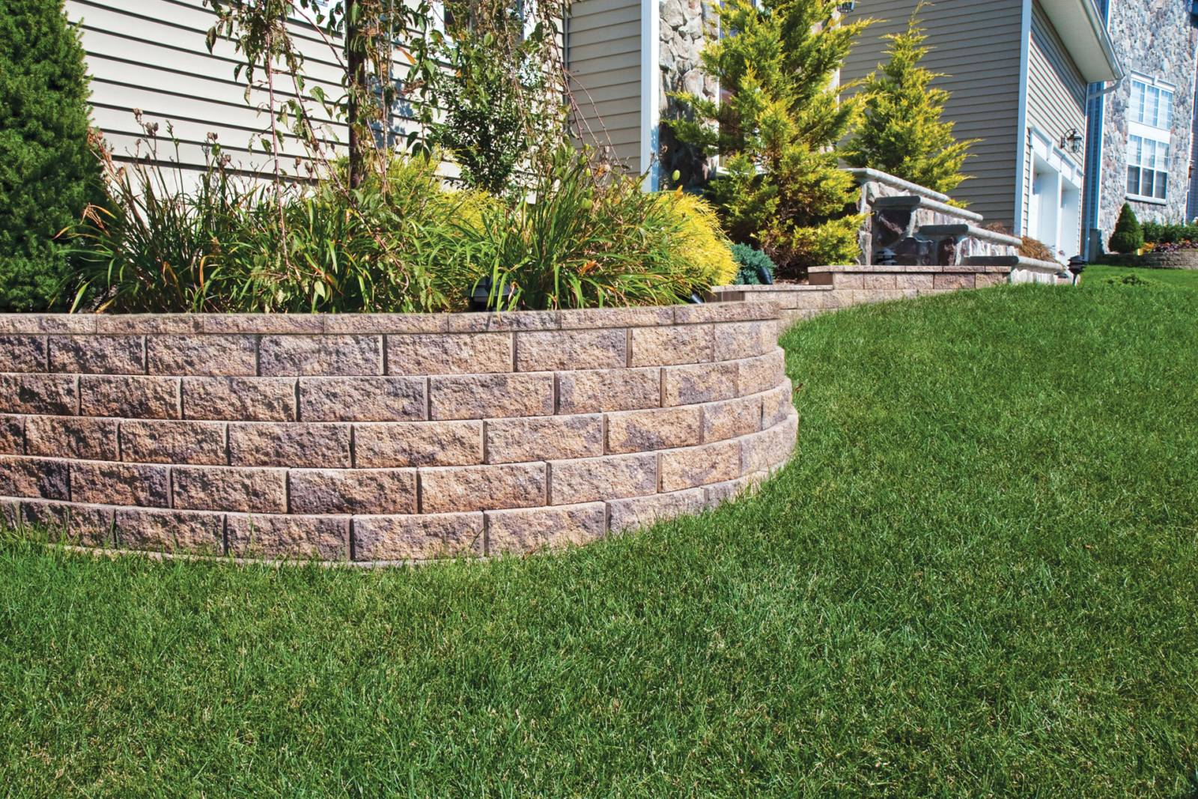

Garden Wall 4″
- 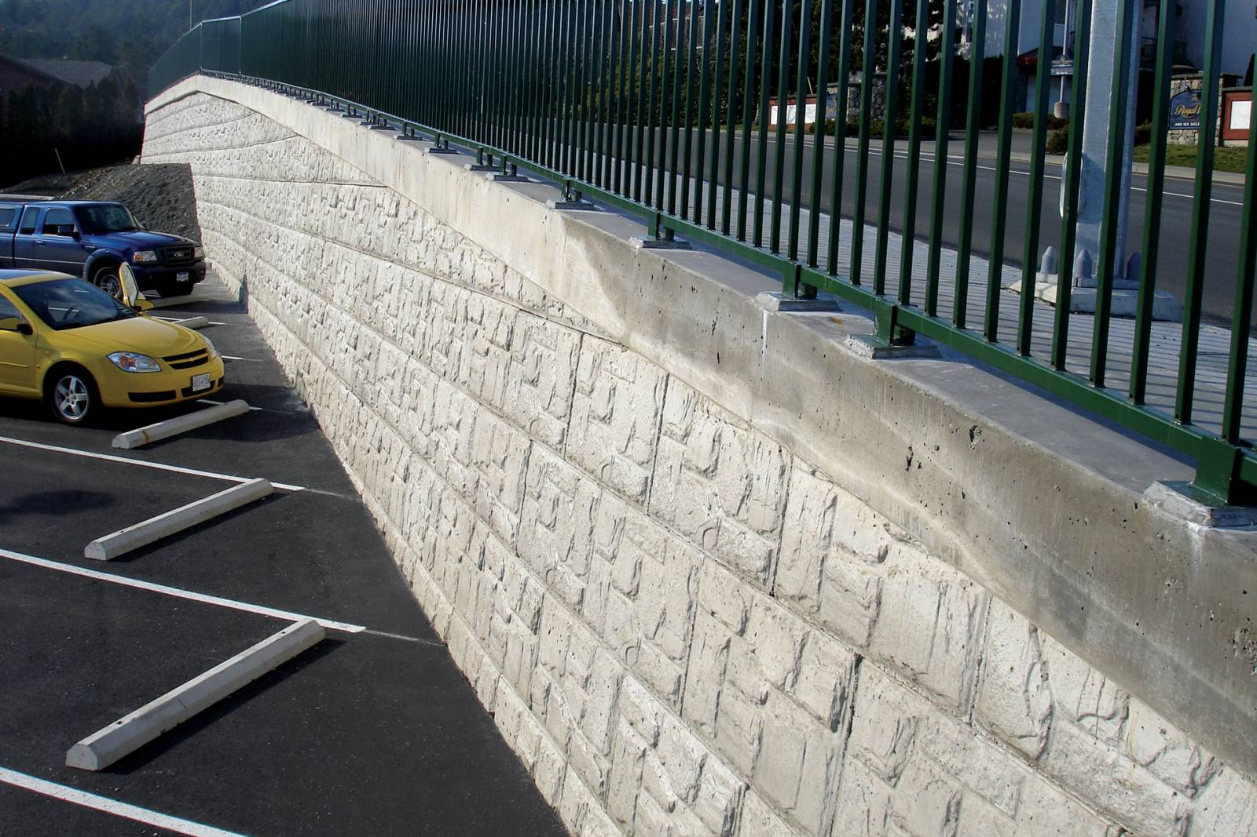

Magnumstone

Request A Catalog
Sometimes you just need to see your product offline. To see our entire product catalog, simply click on the link below to request your own catalog.
LETS GO!

A passion for beauty driven by hardscapes! Progressive, innovative, and reputable quality; let LibertyStone™ products be your project choice.
866-429-4545

OUR PRODUCTS
- TrueTumbled Walls
- Traditional Walls
- TrueTumbled Pavers
- Liberty Pavingstones
- Single-Unit System
- Multi-Unit System

JOIN NEWSLETTER

Web Design by CornerStone Wall Solutions ® Copyright LibertyStone™ Hardscaping Systems Inc. | 866-429-4545 | Contact Us
YouTube

