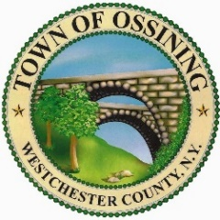 | TOWN OF OSSINING  BUILDING DEPARTMENT  101 Route 9A, P.O. Box 1166  Ossining, N. Y. 10562  Phone: (914) 762-8419 eFax: (914) 290-4656  Website: www.townofossiningny.gov Email: building@townofossiningny.gov

N O T I C E O F O N - S I T E M E E T I N G

NOTICE IS HEREBY GIVEN THAT the Town of Ossining Planning Board Members have scheduled an on-site meeting to walk through the property located at 94 Somerstown Road, Ossining, New York, on Thursday, May 8, 2025 at 5:00 pm. The property is currently under consideration for a 3-Lot Subdivision and Site Plan Review, Wetlands, Steep Slopes and Tree Permit.
The property is owned by Jennifer and Pascal Smith-Couti and is located within the unincorporated area of the Town of Ossining in the R-40 One-Family Residence Zoning District and constitutes lands described on the Tax Map of the Town of Ossining as Section 90.11, Block 1, Lot 1.
Application Materials and Site Plans, titled “94 Somerstown Road Property” prepared by Alan L. Pilch, P.E., ALP Engineering and Landscape Architecture PLLC, originally dated November 22, 2024, with latest revision March 28, 2025 are on file with the Town of Ossining Building Department, 101 Route 9A, Ossining, New York available for public inspection during regular business hours, or can be viewed online at:
https://www.townofossining.com/cms/publications/all-documents/planning-board/planning-board-projects/pbproj-under-review/94-somerstown-road
Please contact our office if you have any questions about the Planning Board meeting process:
914-762-8419.
Emails can be sent to building@townofossiningny.gov

BY ORDER OF THE PLANNING BOARD OF THE TOWN OF OSSINING
Carolyn Stevens, Chairperson
DATED: April 28, 2025

