

Tyler Technologies
Neighborhood Delineation
Procedure

August 8, 2014

Contents

1. Scope 1
2. Introduction 2
3. Data to be analyzed 3
3.1 External Data 3
3.2 Neighborhood Data 4
3.3 Neighborhood Data Form 4
4. Steps in the Analytical Process 7
4.1 Step 1 9
4.2 Step 2 13
4.3 Step 3 13
4.4 Commercial (including industrial and apartment) Delineation 15
5. Necessary Documentation 18
6. References 19
6.1 USPAP 6 19
6.2 IAAO Procedure on Mass Appraisal 19
6.3 Neighborhood Data Form 19
6.4 IAAO – www.iaao.org 19
6.5 ESRI – www.Esri.com 19
6.6 Appraisal Institute – www.appraisalinstitute.org 19
7. Definitions 20

Scope
The procedure on neighborhood delineation will define the processes to be used in the delineation and analysis of neighborhoods for residential and commercial (including apartment and industrial) property in each member jurisdiction of MMRC. Neighborhood delineation and analysis is a study of forces or influences which could be considered to have an effect on property value. The neighborhood rating should be a reasonable fit for at least 50 to 70 percent of the properties located in the delineated area. The actual scope of the neighborhood delineation will depend on whether there is an existing delineation that needs to be fine-tuned or are created from scratch. Either way the basic approach remains the same.

Introduction
Depending on whether the delineation is to be used as part of the cost approach, income approach, market approach a combination thereof, the neighborhood delineation serves two main purposes:
1. Provides a geographical basis for the creation of land value tables, building depreciation tables, income approach tables, value modifiers, comparable sales selection, and MRA (multiple regression analysis) market models.
2. Provides a geographic area to use as a data set for measuring change in value levels over time for the purposes of quality measurement, trending of values by neighborhood (where practiced,) and other statistical reporting, such as on typical structures and value ranges.
If the primary approach to value is the cost method, the neighborhood delineation should consider variables that more directly impact the cost value. These may include year built, effective age, exterior wall type, SFLA, FBLA, physical condition and so on. If the market comparable approach is the primary valuation method, the delineation should consider variables that are market driven. These may include style, grade, neighborhood desirability and median sale price.
The International Association of Assessing Officers (IAAO) defines a neighborhood as:
“…the environment of a subject property that has a direct and immediate impact on its value.”¹
For our purposes a “neighborhood” may be defined as;
“…as the largest geographic grouping of properties where the significant economic forces of those properties are generally uniform”.
The three types of neighborhood boundaries are natural, man-made and political. Natural boundaries are physical in nature like rivers, hills, lakes and ravines. Man made boundaries include streets, highways, railroad tracks, utility right-of-ways and subdivision lines. Political boundaries are established by governmental entities and include school districts, zoning restriction and jurisdictional boundaries.

Data to be analyzed

External Data
To meet the IAAO definition of a “neighborhood” one needs to compare components influencing value. Those four factors are: physical, economic, governmental and social.
A brief discussion of each:
Physical – The most obvious physical factor is location. Virtually all other influences are secondary to location. Other physical factors include topography, availability of utilities, traffic patterns, existence of sidewalks and paved roads and nearness shopping, schools and churches for residential property and a workforce, customer base, and transportation for commercial properties. Another important physical factor is the similarity of property characteristics (age, use, style, quality of construction, physical condition, size of land etc.).
Physical data can be collected during data collection in the case of property characteristics and many of the other data can be obtained using zoning maps, GIS, ortho or street-level photography or websites that provide geographical information.
Economic – These factors are external and include shifts in use (single family area changing to multi-family or privately owned dwellings changing to rentals or leases); changes in job market; new construction; vacancy and changes to amenities (closing of schools or shifts in shopping availability); changes in taxes or addition of special assessments.
Economic data can be gathered by researching changes in the data base
using scripts that track changes in land use code (LUC) building permit records and research into recent changes in the jurisdiction as it relates to its economic health and the job market.
Governmental – Factors include zoning, services like water, sewer and trash pickup, assessments, taxes, fire and police service and proximity to schools.
Governmental data can be found on line. Sites such as www.city-data.com provide statistical information by jurisdiction and city. Local Chamber of Commerce or Visitor’s Bureau websites will provide an overview of the jurisdiction and local Board of Realtor sites may provide rents or asking prices for your area. Frequently GIS maps can be accessed through the Auditor or Assessor’s website and zoning and school districts are usually found there also.
Social – These factors include population density, population demographics, and crime statistics.
Social factors can be identified at the Chamber of Commerce and Visitor Bureau websites that provide jurisdiction profiles and Census sites that provide demographics. Local Realtors and fee appraisers might be able to assist in identifying trends and local perceptions on various areas.

Neighborhood Data
To collect the characteristics needed to define (document) neighborhoods, a form should be developed and utilized. The proposed form can be found in Appendix A of this procedure. These data forms serve three main functions:
1. Provide an opinion of the typical structure, economic factors and conditions with an area considered to be a neighborhood. The data forms provide a benchmark for comparing each property within the neighborhood to each other.
2. Provide a generally similar geographic area to use as a statistical base for sales comparison, both during the initial valuation and years later to measure change and update values accordingly.
3. Provide a basis to allow development of computer assisted land pricing (CALP) tables.

Neighborhood Data Form
The data form allows for a profile of the proposed neighborhood to be developed. This is done manually, using external data and queries that pull data from the CAMA file.
At a minimum, every neighborhood (and form) needs to consider and address the following:
- Area Name – A narrative description of the NBHD area, “Willow’s Peak Sub” or “Center City Ward 2”. It is beneficial to use commonly recognized names for neighborhoods. One can gather these from the assessor, local realtors, local multiple listing services, banks or fee appraisers.
- Neighborhood ID Code – It makes sense to give the digits of the NBHD ID some type of meaning. Example: 01#R06##. ‘01’ first two or three digits might identify the tax district or broad geographical, locally recognized area being delineated; the next digit or set of digits might identify the class of property being valued by the NBHD (Residential or Commercial). The following characters might subdivide the area to identify any number of meaningful characteristics like relative value range, age, relative desirability, suburban, condominium, urban development or any other significant variable that would make the NBHD ID more meaningful.
- Physical Boundary description – Provide the North, South, East and West boundaries. For example: North to Main Street, South to the railroad tracks, East to Route 224 and West to the Buckeye River. A field is provided to include the type or reason for the boundary. They include physical barriers; income level change, value range change, use of land change and other (provide an explanation). Our example included physical barriers (the Buckeye River and the railroad tracks) and possible income or value range changes (Route 224 and/or Main Street).
Characteristics that might be included on a Neighborhood data form:
Tax District/School District
Type/Predominate Land Use/Density – Urban, Suburban, Subdivision, Rural, etc.
Housing Demand/Supply – Refers to availability of houses for sale.
Rate of Turnover/Time on Market – Slow, Steady and Rapid
Neighborhood Life Cycle/Change in Life Cycle – Describes whether a NBHD is improving, stagnant or declining in value and any recent or impending changes to that cycle.
Predominant Improvement Type –Single, Multi or Condominium housing.
Typical Improvement Quality – Refers to the quality of dwelling construction. Can be expressed as mean and median Quality grade or as frequency statistic.
Typical Improvement Age – Refers to dwelling age in years. Can be expressed as mean and median Year Built or as frequency statistic.
CDU Refers to predominant Condition, Desirability and Usefulness assignment.
Predominant Occupancy – Owner or Tenant.
Vacancy – Expressed as a percentage of observed vacant improvements.
Mean and Median Market Value. Based on recent sales within the neighborhood
It is often desirable to provide comments (in narrative form) or the relative desirability of a given neighborhood. This can act as the beginning for review notes that can be used the foundation for final review guidelines.

Steps in the Analytical Process
Delineation should begin at the macro level. In other words, start with fairly general boundaries and work to fine tune them to the micro level. A good starting point is at jurisdictional level. Start by breaking neighborhoods by townships, villages and cities. The example below shows a macro delineation based on jurisdiction. It is easily understood as it follows generally accepted boundaries that taxpayers are already familiar with. The NBHD identification prefix can be tied to the tax district which is geographical. Tarrytown = 01, Irvington = 02, Dobbs Ferry = 03, Hastings = 04 and so on. In some jurisdictions school district should also be considered as if can be a more important value determinant than municipality.
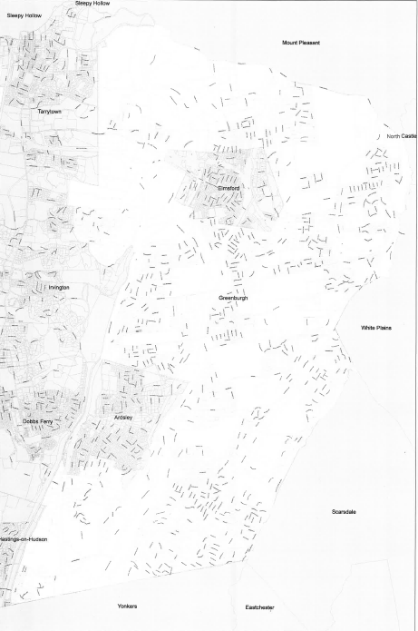
04
02
0 03
01

Within each macro neighborhood there may be smaller homogenous areas that should be identified separately. Frequently unique neighborhoods within a city or village are based on year built in the case of a newer subdivision or a historic district of downtown. Towns may be subdivided based on the proximity to desired amenities, access roads or subdivisions.

Step 1
• Obtain several kinds of maps – Either traditional tax maps or GIS generated maps can be used. Without cluttering the map, it is useful to have sale prices, lot dimensions and jurisdiction or subdivision lines included.
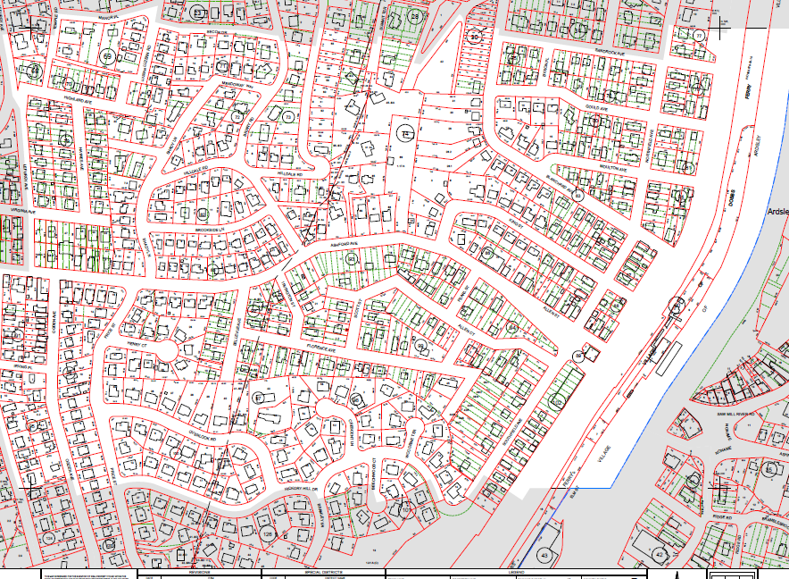
The example above shows a sample of a section with fairly homogeneous land sizes while the example below indicates a change of land size and possible use.
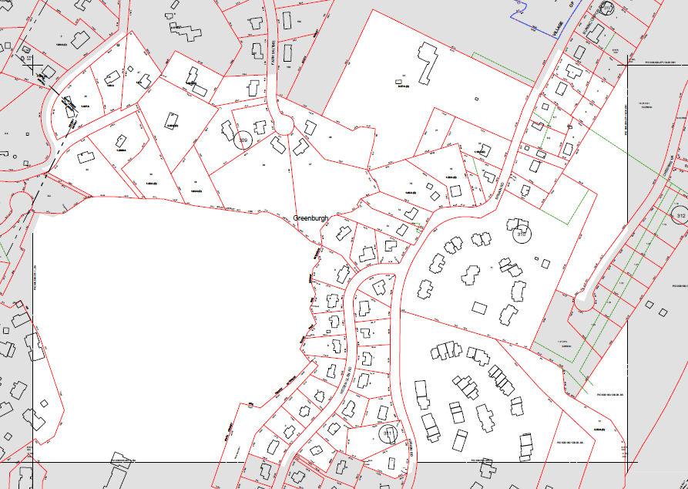

Zoning maps are usually available and can provide information on highest and best use for parcels or restrictions on land use.
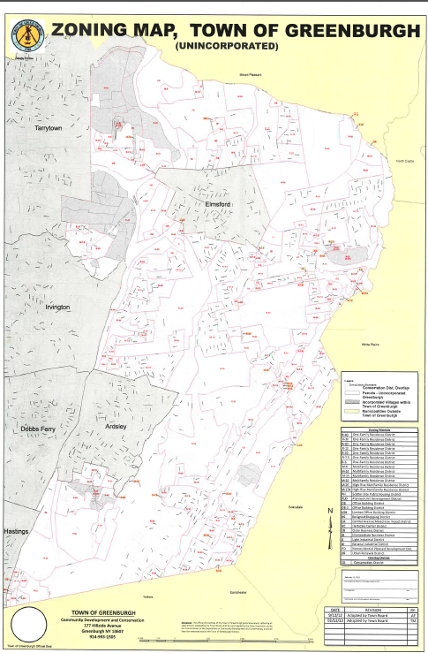

• School District maps (sample below) show school boundaries that also impact tax rates and other variables that affect value.

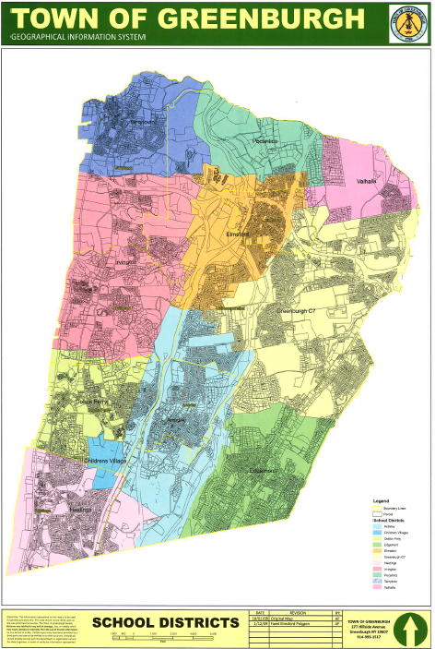

Step 2
• Visually establish preliminary neighborhood boundaries. This can be done initially using land size as a starting point. The age, condition, quality and type of improvement can all be used to set boundaries. One can generate reports from CAMA or use GIS capabilities to highlight the data graphically.

Step 3
• Assemble and analyze supplemental material, including median statistics by tax and school districts
- Field inspect proposed neighborhoods street-by-street
- Establish boundaries and complete NBHD forms
• Analyze each NBHD to ensure the boundaries are appropriate and the NBHD represents a homogenous area.
The example below shows the mean and maximum and minimum year built by NBHD. NBHDs with higher procedure deviation may indicate a need to fine tune the NBHD boundaries.
NBHD | Parcels | Mean | Median | Minimum | Maximum | Std. Deviation | yrblt notes
26R01000 | 20 | 1992.90 | 1993 | 1992 | 1993 | 0.31
15R03000 | 56 | 1979.11 | 1979 | 1979 | 1980 | 0.31
05W02000 | 78 | 1971.96 | 1972 | 1969 | 1972 | 0.34
02R13000 | 29 | 1978.93 | 1979 | 1977 | 1979 | 0.37
03R11000 | 90 | 1992.08 | 1992 | 1991 | 1993 | 0.37
01C06000 | 7 | 2004.14 | 2004 | 2004 | 2005 | 0.38
07R07000 | 16 | 1996.06 | 1996 | 1992 | 2003 | 3.02
25R03000 | 10 | 2002.70 | 2002.5 | 1998 | 2007 | 3.06
08R22000 | 41 | 1989.54 | 1989 | 1986 | 1998 | 3.08
16C24000 | 18 | 1983.72 | 1985 | 1980 | 1987 | 3.16
28R10000 | 31 | 1995.90 | 1996 | 1993 | 2007 | 3.20
08R30000 | 12 | 2000.83 | 2000.5 | 1997 | 2006 | 3.21
16C14000 | 402 | 1975.85 | 1975 | 1973 | 1989 | 3.24
08R31000 | 72 | 1999.13 | 1999 | 1993 | 2005 | 3.26
20R11000 | 35 | 1995.54 | 1994 | 1991 | 2004 | 3.30

Using a program, like SPSS or NCSS, can help generate a variety of reports that can be run to help in verifying boundaries. The histogram below shows the frequency of dwelling year built graphically. If this is run within each neighborhood it may show the level of homogeneity within that neighborhood and whether it is necessary to make additional changes.
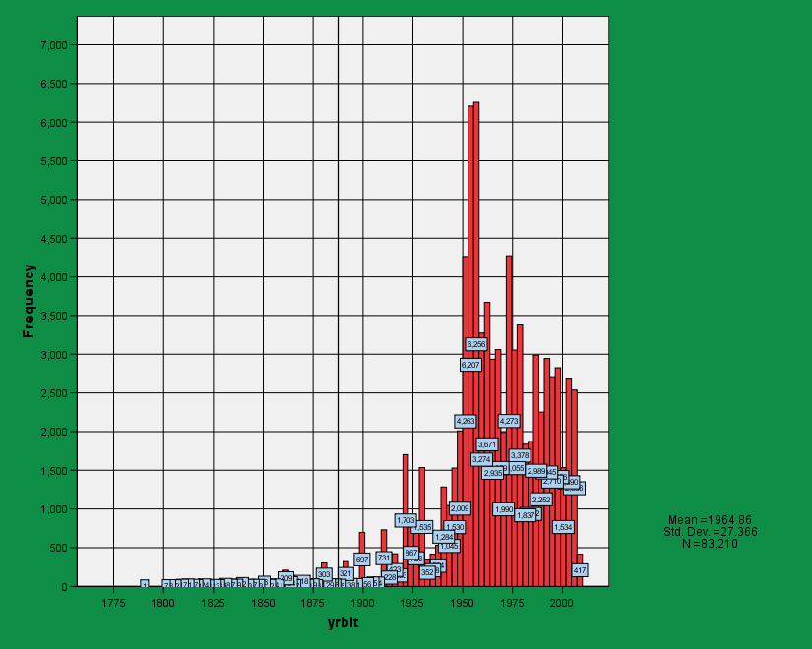

Similar reports should be run for grade, CDU, size, sales price and so on.
This data becomes helpful for comparable sales selection in market modeling. An example is included below of a neighborhood with possible bimodal distribution based on year built and may indicate a need to divide this neighborhood into two distinct neighborhoods.
A statistical profile for each neighborhood should be generated including frequency distribution and relevant statistics for data characteristics. Examples include year built, SFLA, grade, CDU, median/mean value, median/mean selling price, medium/mean land size and style organized by neighborhood. One neighborhood profile sheet should be created for each neighborhood and should contain all the relevant data needed for that neighborhood. An example is included below.
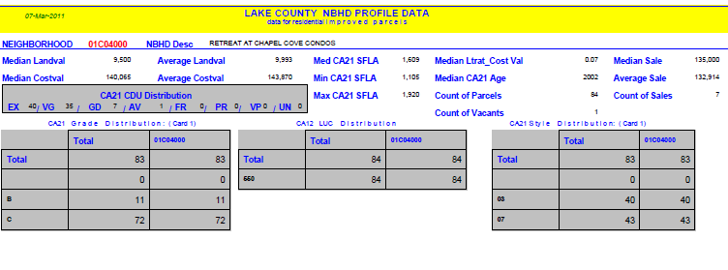
- Establish final boundaries
- Group neighborhoods to allow for wider selection of comp sales
- Summarize, collate and distribute forms

Commercial (including industrial and apartment) Delineation
Much of the foregoing is specific to residential delineation, though the principals are the same for commercial property. Commercial neighborhood coding will depend upon the complexity of the jurisdiction.
It is important that the analyst understand the CAMA system being utilized and how the neighborhood assignment for non-residential properties might affect value. If the income approach is tied to the neighborhood assignment as well as the land tables used for the cost approach, those factors must be considered to ensure the effective use of the neighborhood assignment.
Especially in larger jurisdictions, it is very helpful that the neighborhood assignment for non-residential properties employ a coding system that will immediately describe the value level and location for the reviewer. For analytical purposes (sales ratios and income and expense summaries), it is important that there be enough properties assigned to each neighborhood to make the analysis meaningful. For that reason physical location (CBD, Major Strip, Industrial Park, etc) is often the starting point for commercial neighborhoods, not necessarily ward or township. Logical grouping of relative value levels within each recognized physical location can ensure that there is sufficient data within each neighborhood to result in meaningful analysis of data and results.
EXAMPLE:
Start by grouping individual districts within a Jurisdiction into relative value levels (neighborhoods). If there is a major city, it might stand on its own. If there are older mill towns or small, low valued areas, they might be clustered together based on relative rents and values. Rural townships might be clustered into the same physical neighborhoods, or, perhaps the rural areas could be further broken down into N-S-E-W for their differing rental markets and values.
Identify haw each property’s physical location is identified in the database and how the neighborhood assignment will be used to estimate value. Typically, non-residential locations can be summarized in ten categories like residential, industrial park, major strip, industrial, etc. Generally, rental rates and land values will differ among these locations, so they can be very useful if included in the actual neighborhood number.
Determine how many characters are available to you within the CAMA system and whether they must be numeric or can include alpha characters. Determine what the residential neighborhood schema is and create a schema for the non-residential neighborhoods that is unique and immediately identified as non-residential.
Once the above actions are completed, one might do the following:
The CAMA system allows a maximum of 5 alpha-numeric characters. Residential neighborhoods begin with the 2 digit school district number (all falling between 01-35). The trailing 3 characters are reserved for the neighborhoods located within each scholl district.
Since there are no residential neighborhoods beginning with the numeral 5, the commercial analyst might reserve that (or any other set of numbers between 40 and 99) to designate commercial neighborhoods. Seven “neighborhoods” have been identified geographically and assigned to neighborhoods 51-57. It has been determined that up to 10 value levels will be needed for each physical location.
A commercial neighborhood number might be defined in the example above as first 2 digits beginning with 51-57 to describe physical neighborhood; the third character to identify one of the ten available value levels within the neighborhood and a fourth to identify the physical location of the property (CBD or other).
If neighborhood 51 is the major city located in the jurisdiction and downtown is the highest level CBD (highest level is 1) and CBD = 1 then a property in the downtown CBD is easily recognizable as 5111.

Necessary Documentation
Documentation should include, but is not limited to:
• Neighborhood maps showing boundaries
• Neighborhood profiles for each neighborhood in your jurisdiction
• Neighborhood data forms
• Sales ratio studies summarized by neighborhood
• Frequency distributions indicating the homogeneous nature of the neighborhood.
• Maps with supporting data such as zoning maps, tax district maps, topographical maps

References

USPAP 6

IAAO Procedure on Mass Appraisal

Neighborhood Data Form

IAAO – www.iaao.org

ESRI – www.Esri.com

Appraisal Institute – www.appraisalinstitute.org

Definitions

Aggregate ratio as applied to real estate, the ratio of the total assessed value to the total selling price.
Average deviation In a distribution of values, the average amount of deviation of all the values from the mean value equal to the total amount of deviation from the mean divided by the number of deviations.
Coefficient A value prefixed as a multiplier to a variable or an unknown quantity.
Coefficient of dispersion As applied to an assessment-to-sale ratio distribution, a measure of dispersion in a given distribution equal to the average deviation of the ratios from the mean ratio divided by the mean ratio.
Frequency distribution A display of the frequency with which each value in a given distribution occurs; or in a grouped frequency distribution, a display of the frequency with which the values within various intervals, or value groupings occur.
Mean A measure of central tendency equal to the sum of the values divided by the number. Also referred to as arithmetic average or arithmetic mean.
Median A measure of central tendency equal to that point in a distribution above which 50% of the values fall and below which 50% of the values fall. The 50th percentile. The 2nd quartile.
Mode A measure of central tendency equal to the value occurring most frequently in a given distribution. In a grouped frequency distribution, the mode is equal to the midpoint of the interval with the greatest frequency.
Normal distribution A distribution in which all the values are distributed symmetrically about the mean value, with 68.26% of the values falling between +/- 1 procedure deviation, 95.44% between +/- 2 procedure deviations, and 99.74% between +/- 3 procedure deviations.
Percentile rank The relative position of a value in a distribution of values expressed in percentage terms; for instance, as applied to an assessment-to-sale ratio distribution, a ratio with a percentile rank of 83 would indicate that 83% of the ratios were lower and 17% of the ratios were higher than that particular ratio.
Precision As applied to real estate, it refers to the closeness of estimated value to actual selling price on an aggregate basis.

